FREQUENCY FILTRING – GROUP 13

Objective: To create a GUI and perform various frequency filtering techniques like Low Pass, High Pass, Band Reject, Band Pass and Band Notch filtering techniques.

Introduction: Frequency filters process an image in the frequency domain.  The image is Fourier transformed multiplied with the filter function and then re-transformed into the spatial domain. Attenuating high frequencies results in a smoother image in the spatial domain, attenuating low frequencies enhances the edges.

Implementation:

a)FFT

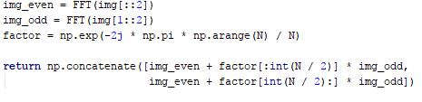

**Time Taken:**

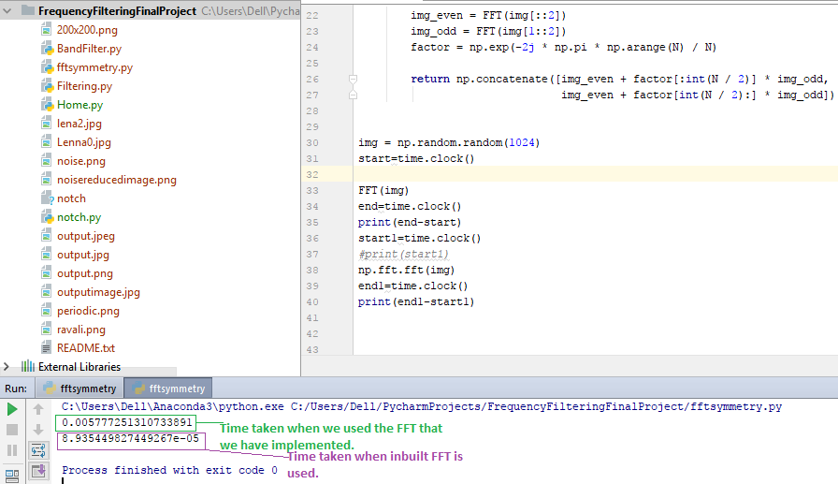

b)Low-Pass Filters

Low-Pass filters are also known as Smoothening or Blurring Filters. Using a low pass filter tends to retain the low frequency information within an image while reducing the high frequency information.

Following are the low pass filter we implemented.

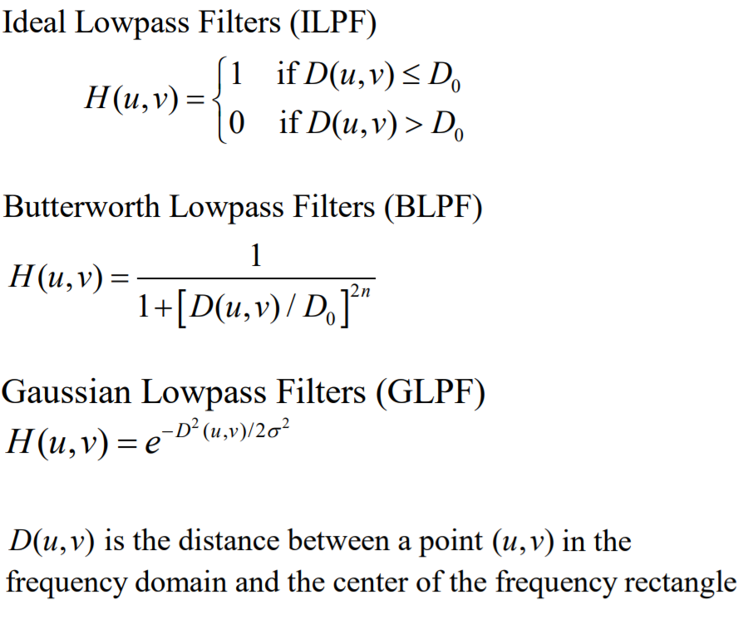

c)High-Pass Filters

High-Pass filters are also known as Sharpening Filters. A high-pass filter can be used to make an image appear sharper. These filters emphasize fine details in the image. High-pass filtering can often improve an image by sharpening detail, overdoing it can actually degrade the image quality significantly.

For high pass filtering we implemented ideal, Gaussian and Butterworth filters the formula for it is simple on minus the low pass filter.

e) Band-Reject Filters

A band reject filter is useful when the general location of the noise in the frequency domain is known. A band reject filter blocks frequencies within the chosen range and lets frequencies outside of the range pass through.

We have implemented band reject filter for ideal, Gaussian and Butterworth filters. Following are the formulas used for it.

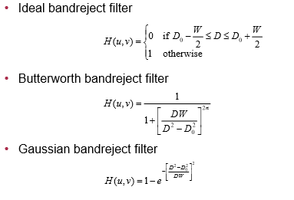

d)Band-Pass Filters

Band pass filters are a combination of both low-pass and high-pass filters. A band pass attenuates very low and very high frequencies, but retains a middle range band of frequencies. Band pass filtering can be used to enhance edges (suppressing low frequencies)while reducing the noise at the same time (attenuating high frequencies).

We implemented band pass filter for ideal, Gaussian and Butterworth. The formula used for it simple one minus band reject filter.

f)Notch Filters

Unlike the Band reject and Band pass filters which operate on specific frequency bands, Notch filters operate on small regions of frequency rectangle. A notch filter rejects (or passes) frequencies in a pre-defined area (neighbourhood) about the centre of the frequency rectangle . It operates in a symmetrical manner.

For the implementation of the notch filter we have provided the user with dft of the image he can drag and cover the noise area to get the filtered image.

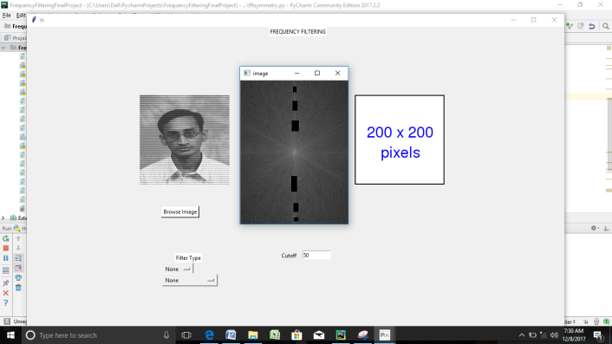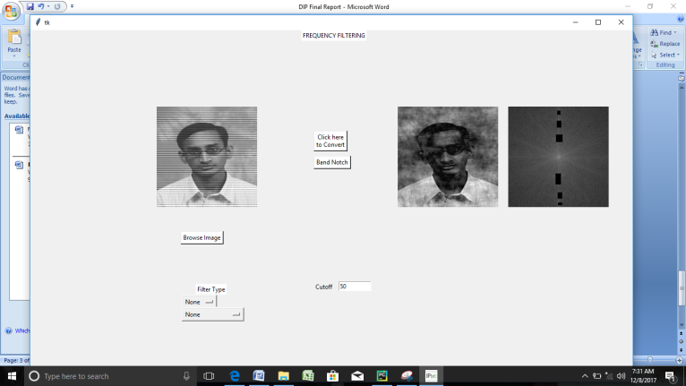

Implementation of GUI

We have used TKinter for the implementation of GUI